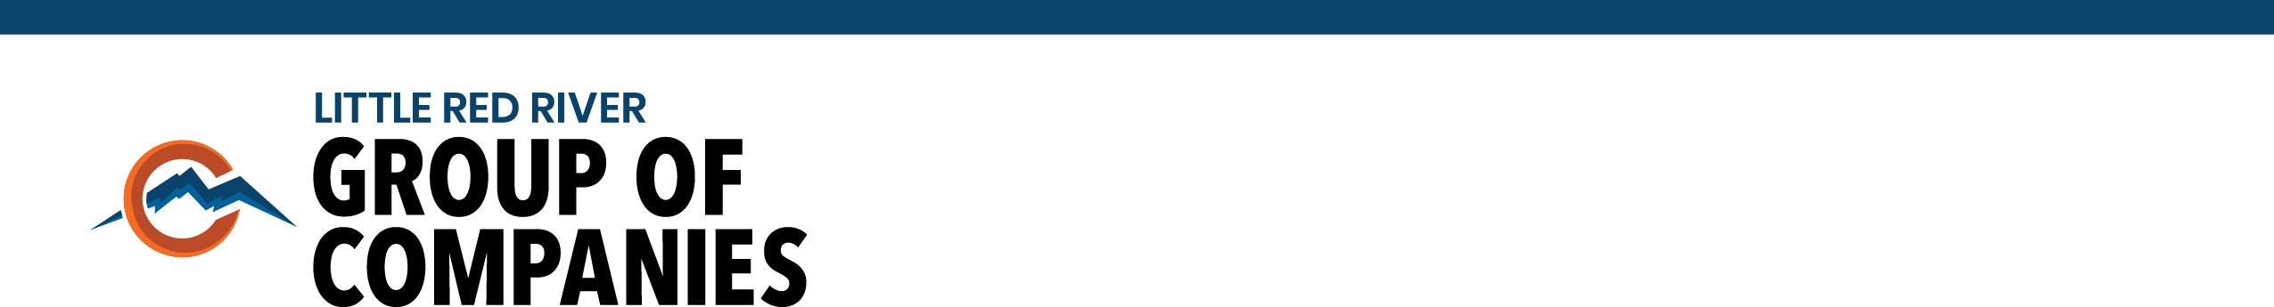
December 14, 2020

Corporate News Release

To our stakeholders, the Members of the Little Red River Cree Nation, welcome to the first of what will be a quarterly sharing of information on the activities of your Group of Companies.

In March of this year the LRRCN finalized a restructuring of the companies separating the corporate organization from the LRRCN and placing them under the governance of a separate Board of Directors.

Why was this done?

There were several sound reasons supporting this decision.

The first was to protect Chief and Council from any litigation or liability related to the operation of the businesses and to allow Chief and Council to focus their time on governing LRRCN.

Secondly, to ensure the corporate group is focused on economic growth to generate profits from sources external to LRRCN which can flow back to LRRCN for the long-term benefit of members.

Another reason was to obtain external business expertise from individuals with significant business experience to support the development of new business ventures and existing businesses.

The members of the Corporate Board of Directors of Little Red River Group are:

Dumaine Arthur Cree Nation member
Hales Murray Retired CPA
Hjlesvold Brian Retired banker; Corporate Secretary
Sewepagaham Conroy Chief of Cree Nation, Board Chair
Williams Mark CFA® Charterholder & President of Aboriginal
Investment Consulting LP

One of the major undertakings of the new Board of Directors was to conduct a search for a Chief Executive Officer to lead the Little Red River Group of Companies Inc. This search was completed with the successful recruitment of an experienced Chief Executive Officer in August.

Who is your new Chief Executive Officer?
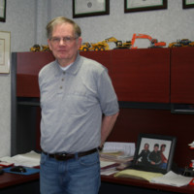
My name is Barney Dohm and I am very excited to share my 20+ years of multi industry experience to help grow the LRR businesses in a safe and sustainable manner.

Prior to joining Little Red River Group I was the President & CEO of the ADK Corporate Group in Fort Liard, NT for 7 years. The ADK Corporate Group is the economic business arm of the Acho Dene Koe First Nation.

My formal education includes an undergraduate degree in Business and a Masters of Science degree in Project Management. My business experience includes: Development of safety systems & COR Certifications; Heavy civil construction including oil & gas development & well reclamations; single, multifamily residential construction; and development of joint ventures.

I have two sons, one daughter-in-law and one grandchild. My favorite hobbies are fishing, learning through life experiences and continuing formal education in addition to continuing to support Scouts Canada as a senior level Scouter and Trainer.

Now let’s review what your individual companies are doing.

Little Red River Group of Companies

A critical component for our companies to be able to pursue projects in most industries is to have a Certificate of Recognition (COR). Without COR accreditation our companies would not be allowed to work on oil & gas sites as well as most construction sites severely limiting our ability to prosper. A COR accreditation tells our clients and potential clients we have in place industry approved safety systems to ensure the safety of our employees.

To ensure we remain on track to continue to be COR certified we have recently amended our corporate safety manuals and revised our safety forms where required.

As your Chief Executive Officer, I am committed to supporting the development of our employees through mentorship, coaching and the provision of skills training be it in the form of management courses or apprenticeship programs to train journeyman carpenters, electricians, plumbers, or other relevant skills related to our businesses. Most importantly, I am committed to ensuring a safe workplace for all employees!

Caribou Mountain Construction

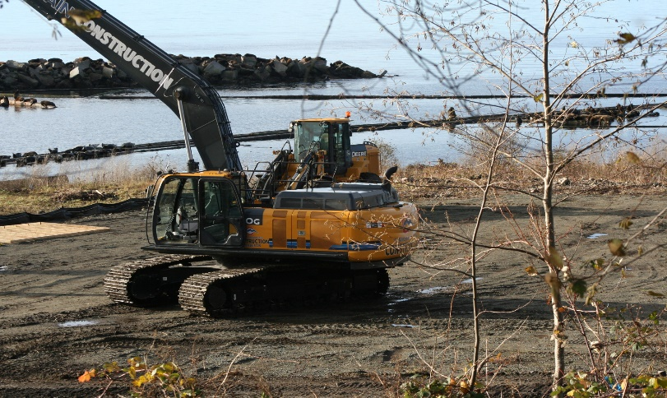
(Long-stick hydraulic excavator working in Powell River)
An experienced management team directed by Edwin Martineau has been acquired to manage the expansion of your company into civil and marine related projects.

Specifically, we recently secured the first bonding for the company to tender and complete a project for the Town of High Level.

The company has successfully bid on two marine projects in Vancouver and Powell River, British Columbia., both of which are in various project stages.

In establishing the marine division, we now own one of only three Long-stick hydraulic excavators in North America specifically configured for saltwater excavation work.

In the spring we expect to be hiring between 5 and 10 employees for the construction of the John D’Or Landfill project.

Wildland Firefighters

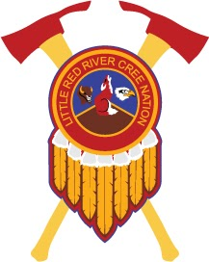
Under the leadership of Harvey Sewepagaham this company has recently obtained contracts to build the annual ice bridges between the communities and High Level, Fox Lake Feeder Vegetation Maintenance and FRIAA Fire Smart Program. Looking forward a few months and dependent on the severity of fire season we would expect to be hiring between 27 and 100 employees. The long-standing traditions and Pride of our Firefighters stands strong and will continue to do so for the long term.

Caribou Mountain Homes

This business was acquired in 2019 for the primary purpose to build homes for the LRRCN offsite and then transport them to serviced lots in the community. At this point in time the company has built 12 homes. In addition, Osbourne and his team have been constructing 2 daycares, a nutrition center, a couple of shops and renovating the old health center.

To date the construction of homes for the LRRCN have relied on the standard stick-frame construction method. Early in the new year the use of Structural Insulated Panels (SIPs) will be the new method of construction with the panels being purchased from a plant in Ontario. These SIPs will provide a greatly reduced construction time for homes while also providing significantly lower energy costs to the future homeowner.

Caribou Mountain Propane LP

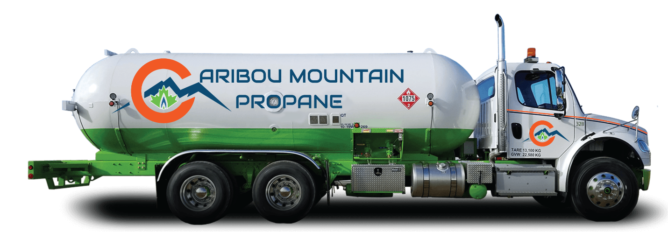This business started operation on December 2, 2020, as a 50/50 partnership between CanGas and Caribou Mountain Investments LP a member of the Little Red River Group of companies to reduce the costs of Propane to the LRRCN and each and every member.

Annual savings to the LRRCN are expected to be in the hundreds of thousands of dollars and each individual member of the community at today’s prices can expect to see a cost savings of upwards of $400 on a 1000-liter purchase.

Caribou Mountain Retail Center

Opening in June 2021 at 12 Mile!

Currently under construction our new retail center will include a Petro Can Gas station, convenience store with provincial lottery, burger/chicken fast food and a Country Style donut store.

The site will also have the propane distribution center for the distribution of fuel by Caribou Mountain Propane.

Phase II of this project is looking at the potential for inclusion of a grocery store.

Caribou Mountain Forestry

Caribou Mountain Forestry (CMF) manages Forest Management Unit F23 (FMU F23) through renewable coniferous and deciduous timber harvest permits with the Alberta government.

CMF deals with local processing facilities for timber sales and manages all silvicultural liabilities after harvesting is complete. The silvicultural liabilities include site preparation, tree planting operations, and all post-harvest surveys required by Alberta which ensure provincial growth standards required for a successful plantation.

In the 2019-2020 harvest season; CMF harvested roughly 170ha of coniferous timber in the Wentzel 1 operating area; roughly 10 km to the east of John D’or Prairie. These harvest areas will be tree planted in the summer of 2021; with over 300,000 white spruce seedlings. CMF is working with an Alberta based contracting company for the successful delivery of the project. There will be numerous employment opportunities for LRRCN members over the summer and fall with CMF.

CMF implemented an Alberta Vegetation Inventory (AVI) renewal for FMU F23 in the fall of 2018. This AVI project is currently ongoing and has an estimated timeline for completion for December of 2021. The AVI renewal is the process of using high resolution imagery and defining the exact species composition, and age class of all forested areas in FMU F23.

The harvesting plans for FMU F23 in the 2020-2021 harvest season are currently under discussion for extracting timber in the Harper 3 operating area: roughly 45 km south of Fox Lake.

CMF is currently exploring different management approaches for FMU F23; and is working with the Government of Alberta regarding these alternative management approaches.

Tree planting activities in the summer of 2021 should see 15-20 LRRCN members employed.

Nations Translations Group Inc.

Nations Translation Group was acquired in March of 2020 as a partnership with another First Nation member. It is located in Ottawa and provides a variety of translation services including recently acquiring a contract with RBC to translate their services to many First Nation languages. Several other large industries are pursuing our services to enhance the translation of First Nation languages.

LRRCN Employment

At December 10, 2020 the Little Red River Group of Companies had a total of 102 employees directly involved in the operation of the businesses. Of the 102 employees 73 were LRRCN members.

Payroll dollars to LRRCN members was $2,548,000 thus far in 2020!

